**Questions**

1. Write a function that prints the numbers from 1 to 100. But for multiples of three, print "Fizz" instead of the number, and for the multiples of five, print "Buzz". For numbers that are multiples of both three and five, print "FizzBuzz".

**CODE :**

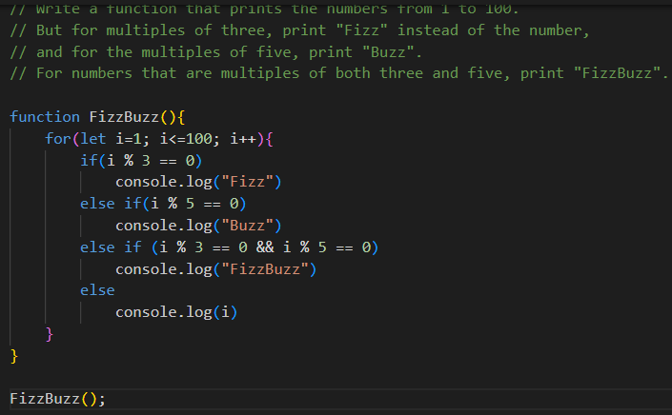

**OUTPUT :**

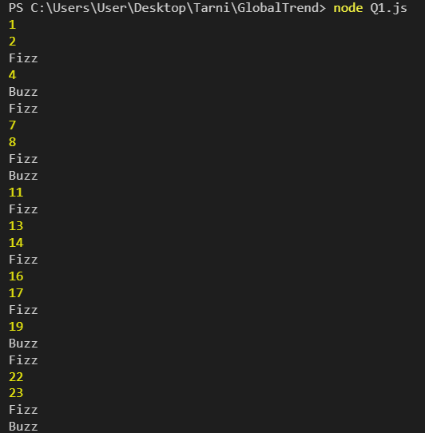

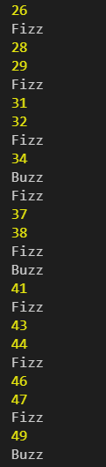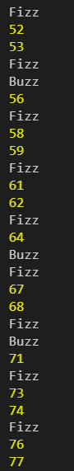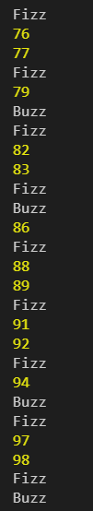

1. Write a function that takes a string input representing a simple arithmetic expression (only addition and subtraction) and returns the result.

**CODE :**

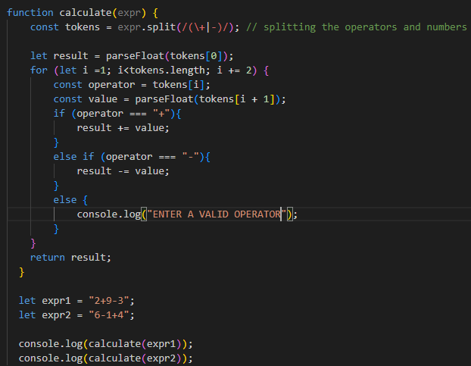

**OUTPUT :**

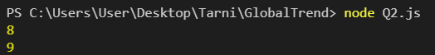

1. Write a function that takes a nested array and returns a flattened array.

**CODE :**

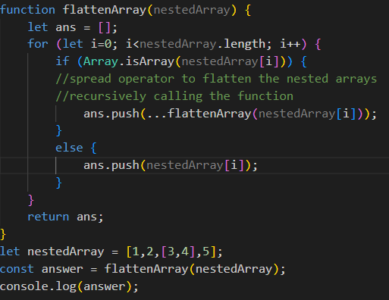

**OUTPUT :**



1. Write a function that checks if two given strings are anagrams of each other.

**CODE :**

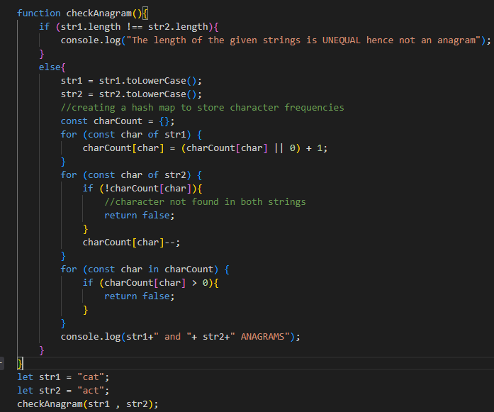

**OUTPUT :**



1. Write a function that takes an array and returns a new array with duplicates removed.

**CODE :**

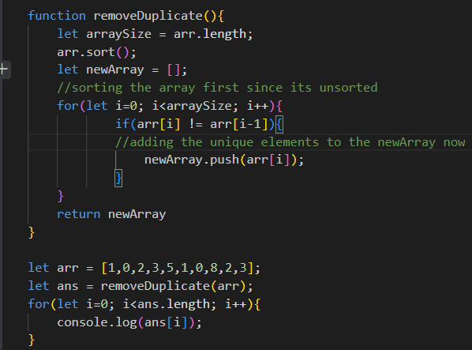

**OUTPUT :**

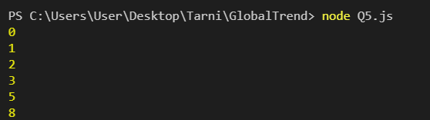

1. Write a function that takes a string and capitalizes the first letter of each word in the string.

**CODE :**

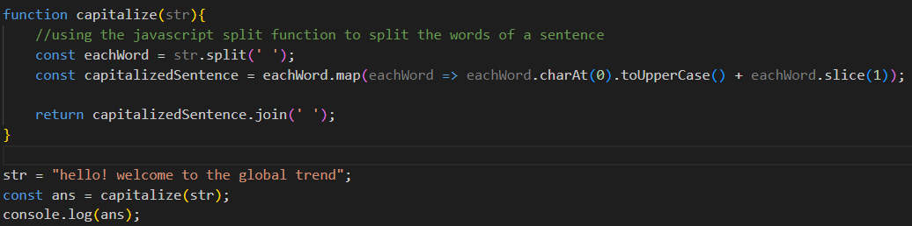

**OUTPUT :**



1. Write a function that generates the first n numbers of the Fibonacci sequence.

**CODE :**

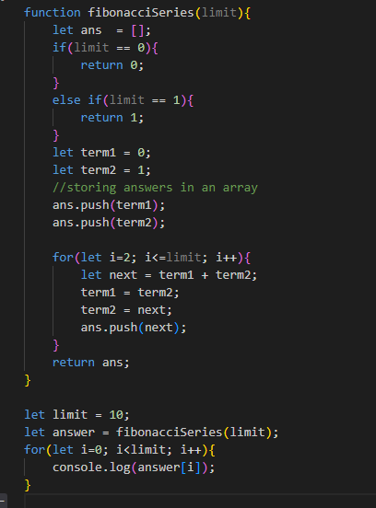

**OUTPUT :**

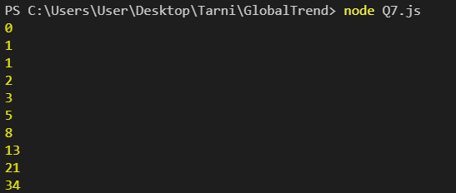

1. Implement a simple HashMap class with put, get, and remove methods.

**CODE :**

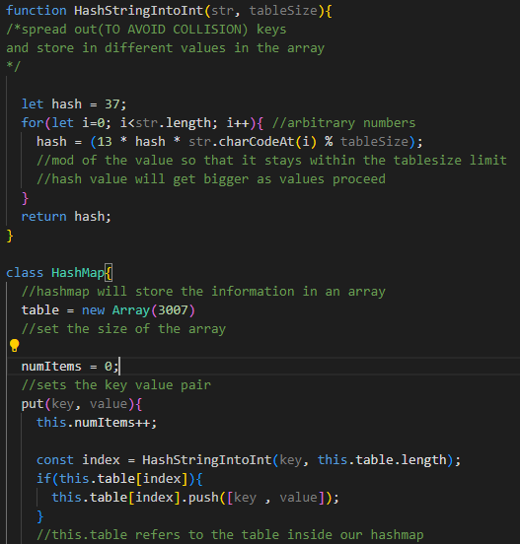

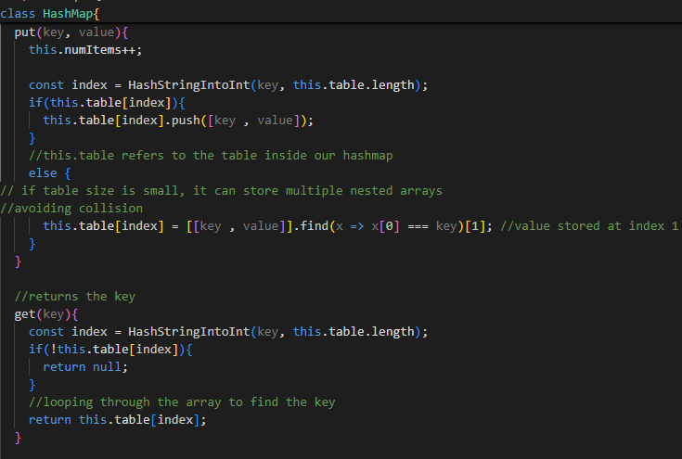

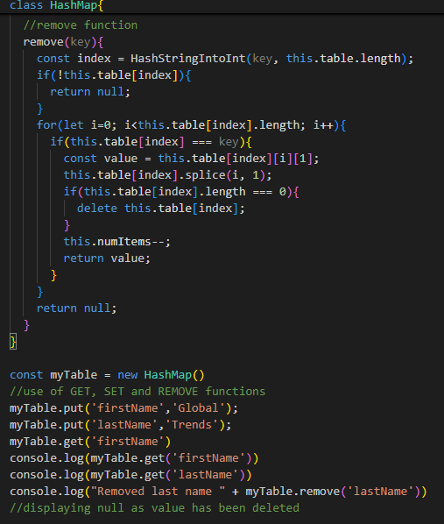

**OUTPUT :**

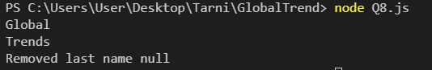

1. Write a function that filters out even numbers from an array.

**CODE :**

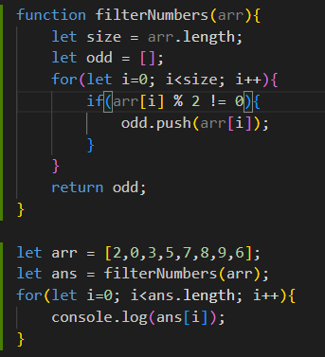

**OUTPUT :**

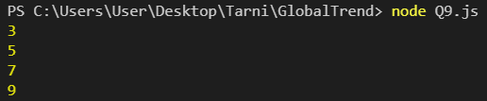

1. Write a function that converts a given string to title case (capitalizing the first letter of each word).

**CODE :**

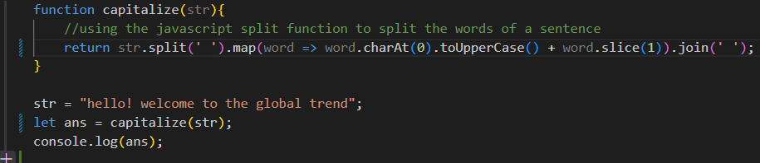

**OUTPUT :**

